**Experiment – 8**

**(By Aman Tyagi)**

**Aim:** Understanding docker swarm.

1) Making the manager

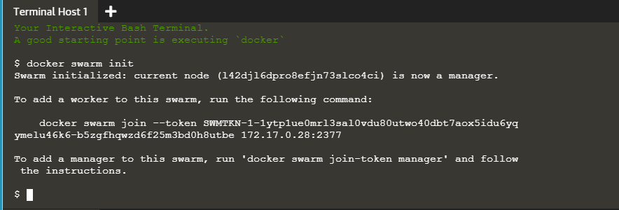

2) Adding a node to the manager

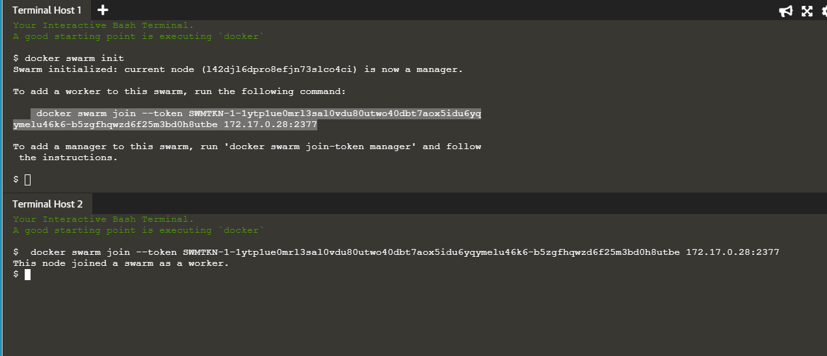

3) Running docker node ls on the manager

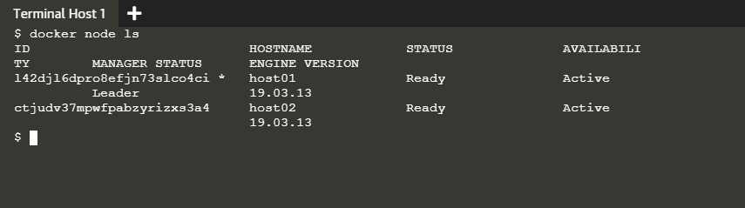

4) Running docker node ls on terminal 3 which is not connected to the manager

